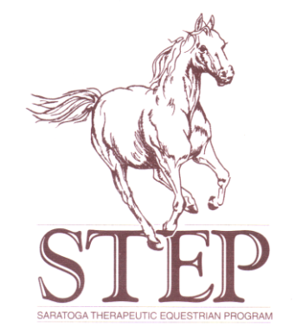 | STEP UP at New Forest Equestrian Centre  P.O. Box 2918  Glenville, NY 12325-0918  Phone (barn): 518 374-5116

Dear Parents and Friends of STEP,

Welcome to the 2020 season at STEP, our 34th year of service! We hope that you will be joining us soon for many riding sessions with our equine therapists!

Detailed below is important information concerning lessons, client evaluation and registration. Please review the information closely and don’t hesitate to follow-up with Kay if you have any questions.

Registration
ALL RIDERS must register yearly with STEP to participate. This fee covers mailing, printing, and to reserve a spot in the program.
FEE: $35 – Must be returned with Registration form to be considered.

Evaluations/Re-evaluations
ALL RIDERS must schedule an appointment for an evaluation (new riders) or re-evaluation for
(returning riders). These non-refundable fees are as follows:

FEES: Hippotherapy: $70 STEP Up: $60 Alternative Programs: $60

Lesson Plans & Fees
A. Hippotherapy (therapy session w/ licensed PT)……………….. $70 per session
B. Private STEP-Up (30 min session)…………………………….. $60 per lesson
C. Semi-Private STEP-Up (45 min session)………………….…. $60 per lesson
D. Able-bodied Sibling/Companion Rider …………………. $35 per lesson
E. Equine Experiential Learning (groups)……………………. (special group rates)
F. STEP from the Ground up……………………………………. $60 per session
Other Specialty programs and K’s Kamp 4 Kids : Please call for rates

PLEASE NOTE: Our STEP staff, licensed Physical Therapists and PATH certified instructors will determine the equipment, horse and therapy session placement appropriate for the rider upon evaluation.

PAYMENT
* All lessons are to be scheduled and paid in advance in a minimum of 4 week blocks.
* One (1) make-up lesson is permitted per session. The make-up lesson is to be scheduled within the current session timeframe and can not be carried over to the next session unless extenuating circumstances and advanced notice.

DELIQUENT PAYMENTS
PLEASE NOTE: We understand there are extenuating circumstances and you must contact us immediately to make payment arrangements or you will be placed on hold. Those failing to do so will forfeit their spot in the program and be assessed a fee equal to the session missed.

Additional

Scholarships: call registrar for information on requirements for scholarship opportunities.

Insurance: Must notify Therapist at evaluation method of payment. Additional FEES APPLY for letters of necessity and processing medical billing. We do not participate directly and this takes extra time for our therapist to complete.

Lesson Cancellation Policy: Please refer to parent handbook. PLEASE DO NOT BE TARDY
We must be called 24 hrs in advance or a fee equal to the cost of the session will be deducted from your account. Please call Kay (518 366.5221) immediately for medical emergencies or other extenuating circumstances and also call the stable at 518 374.5116 and leave a detailed message.

HOW TO GET STARTED

STEP 1: Register your rider in the program by completing the attached registration form and
Supporting documents then mail them to the below address with the $35.00
Registration Fee. Make check payable to STEP.

STEP 2:Make sure all Medical supporting documents are sent to the MD and returned to STEP.
New Riders: Medical documents must be returned to STEP prior to evaluation.
We cannot schedule evaluations without this information.
Returning Riders: You may bring supporting documents with you the day of the re-eval.
Any other arrangements must be made with Kay.
STEP 3: Our STEP Registrar will call to schedule time and date of Evaluation
or Re-Evaluation once your forms and check have been received.

STEP UP at New Forest Equestrian Center
P.O. Box 2918
Glenville, NY 12325-0918
ATTN: Kay White PT

Please do not hesitate to call us with questions. Space is limited in our program and time slots are on a first come, first served basis.

Thank you and welcome!

Sincerely,

Karen Stanley- White, P.T. MSCS AHA/PATH
Executive Director STEP

